VI. CARRIER MATERIALS

Peat is the most commonly used solid carrier in making legume inoculants. It is also the most dependable because rhizobia in a peat carrier remain viable longer both in the package and on the seed. However, good quality peat is not available in many countries.

Chemical and physical analyses of carrier materials are helpful but do not confirm the quality of a carrier. The quality can be determined only by placing viable rhizobia in the material and monitoring the growth and survival of rhizobia over a period of 6 months or longer.

The important qualities of a carrier material in legume inoculant production are:
1. Good absorption capacity,
2. Easy to dry and grind,
3. Nontoxic to rhizobia,
4. Free of abrasive minerals,
5. Low in content of soluble salts,
6. Easy to sterilize,
7. Available in adequate amounts at a reasonable cost.
Many other materials -- bagasse, sugar cane filter mud, coir dust, coal, lignite, charcoal, straws, various compost mixtures, clays, and minerals such as apatite and vermiculite, have all been tested and are acceptable (Date and Roughley, 1977; Burton, 1979; Paczkowski and Berryhill, 1979). Nonetheless, it is still desirable to carry out tests with each individual material because of the wide variation which occurs within each type of carrier. Some of the chemical and physical properties of materials used as carriers in inoculant production are given in Table 6.

It is difficult to make valid comparisons of organic materials used as carriers. In essence, the choice of a carrier material should be based on its ability to support large populations of rhizobia over a long period of time. This will depend upon the processing as well as the physical and chemical properties of the substance. Processing equipment can be far more expensive than the fermentor equipment used in growing rhizobia.

Table 6. Some physical and chemical characteristics of various carrier materials (Subba Rao, 1983).
Carrier | Organic Matter  % | Total N  % | Bulk  Density  g/cc | Porosity  % | Water-holding  Capacity  %
Sedge Peat | 76 | 0.95 | 0.82 | 45 | 200
Farm Yard Manure | 79 | 0.93 | 0.79 | 55 | 153
Filter Press  Mud | 76 | 0.83 | 0.75 | 56 | 155
Compost | 55 | 0.55 | 0.75 | 59 | 171
Vermiculite  Clay | 1 | 0.01 | 0.98 | 63 | 152
Lignite | 75 | 0.31 | 1.08 | 35 | 198
Charcoal | 22 | 0.01 | 0.43 | 73 | 200

Some of the properties of a U.S. processed peat (DEMILCO) are given in Table 7

Table 7. Sieve analysis of DEMILCO processed sedge peat carrier
Particle size | Powder Inoculant | Granular Inoculant
850 - 1200 μm *  (16 - 20 mesh) | 0.00% | 0 - 10%
600 - 850 μm  (20 - 30 mesh) | 0.00% | 30 - 40%
300 - 600 μm  (30 - 50 mesh) | 1.00% | 50 - 60%
150 - 300 μm  (50 - 100 mesh) | 5.10% | 4.0%
60 - 150 μm  (100 - 200 mesh) | 5-10% | Trace
<60 μm  (through 200 mesh) | 80-90% | Trace

*Micrometer - mesh - ASTM (Amer. Soc. Testing Methods)
The flash dried peat is sieved to separate particles in the range between 16 and 40 mesh (400 - 1200 micron diameter) to obtain carrier for the granular inoculant. the peat granules are thus natural and of various sizes. The fine powder carrier is obtained by passing the flash dried peat mix through a high speed hammermill and then screening to obtain a high percentage of particles of the 60 to 100 micron diameter size.

The chemical analysis of the DEMILCO peat is as follows: organic matter 80 - 85%; nitrogen 1.5 - 2.0%; crude ash 15 - 20%; and a pH of 4.5 - 5.0.
A. Sterilization
Sterilization or partial sterilization of peat and other organic carrier materials can greatly improve the suitability of the material as a carrier. Generally, inoculants prepared from air-dried, unsterilized peat have a short shelf life. Heat-treated peat, even without aseptic handling afterward, is usually far superior to air-dried or untreated peat. Sterilization may be even more important when nutrients or undecomposed organic substances are added to the carrier because of the increased competition between the rhizobia and other microorganisms for the nutrients provided.

Roughley (1967) reports that dry heating peat above 100°C causes degradation with toxic effects on rhizobia. In the United States (DEMILCO), shredded peat is passed through a revolving drum with an inlet air temperature of 650°C and an outlet temperature of 121°C. The flash-drying, similar to that used in dehydrating high quality alfalfa, produces no adverse effects. The moisture content is reduced from approximately 50% to 8% in a matter of seconds.

In South Africa, Strijdom (1981) reports great success in steam-sterilizing peat at 121°C for 3.5 hours. Inoculants prepared with the steam-sterilized peat reach populations of viable rhizobia in excess of 1 X 10⁹ and maintain this level for 6 months and longer. Steam sterilization of peat for 3.5 hours at 121°C was just as effective as gamma irradiation at the 50 kGr (5 X 10⁶ rad) dosage. Complete sterilization of the peat does not appear to be necessary. Growth of cowpea rhizobia was just as good in the peat receiving 25 kGr (2.5 X 10⁶ rad) irradiation as it was in the peat receiving the higher 50 kGr (5 X 10⁶) treatment. Strijdom (1981) points out that optimal sterilization treatments may vary with Rhizobium strain and species. Gaseous sterilization of peat with either ethylene oxide or methyl bromide caused development of unfavorable side effects and is not considered satisfactory.

The amount of time needed to sterilize peat or other solid carriers will vary with the moisture content of the substance. Dry peat is more difficult to sterilize by autoclaving than is wet peat. A moisture content in the range of 8 to 12% (wet basis) in the carrier is preferred in making inoculants. Wetting peat with a moisture content of 6% or lower liberates energy as heat. This heat of wetting may result in a high temperature and killing of rhizobia, particularly when the freshly made inoculant is placed in layers thicker than 25 to 30 cm.

A high moisture content in the carrier favors sterilization by heat, but high moisture reduces the amount of broth culture which can be added. This can be overcome, however, by using a more concentrated broth culture of rhizobia.

B. Pure Culture Rhizobium Inoculants

The production of pure culture Rhizobium inoculants requires that the carrier material, calcium carbonate and any other amendments be placed in the package and sterilized as a unit. The polyethylene flexible film package is satisfactory when gamma irradiation is the sterilizing agent. The packages containing the carrier are sealed, stacked in cardboard boxes and irradiated.

With steam sterilization, a polypropylene flexible film is required. The packages can be filled with the carrier and the open end folded over during sterilization to prevent bursting while being autoclaved. The packages should be sealed quickly after sterilization. An alternate method is to fill the package with carrier and press to remove air from inside before sealing. The sealed packages can then be safely autoclaved.

In order to maintain a pure culture of rhizobia, the package containing the sterile carrier must be inoculated aseptically using a hypodermic syringe. The broth culture is then worked into the carrier by manually kneading the package. One or two weeks are required for the rhizobia to attain the desired concentration in the package.

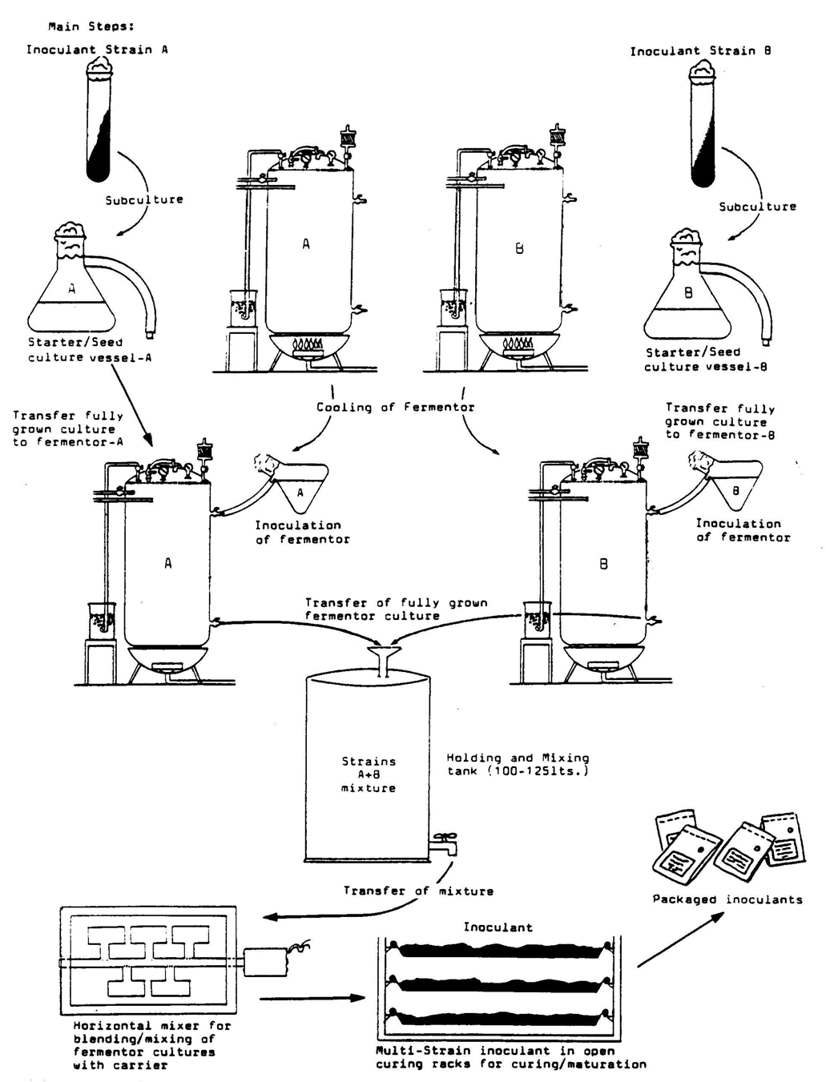

Figure 3. Multi-strain Inoculant Production

